SyncBox

Requirements Specification

For Circuit and Firmware

Version <1.0>

Revision History

|  |  |  |  |
| --- | --- | --- | --- |
| **Date** | **Version** | **Description** | **Author** |
| 24/Jan/21 | 1.0 | Initial system expectations and requirements | Altay Brusan |
| 28/Oct/21 | 1.1 | Table of contents updated | Altay Brusan |
|  |  |  |  |
|  |  |  |  |

Table of Contents

1. Introduction 4

1.1 Purpose 4

1.2 Scope 4

1.3 Definitions, Acronyms, and Abbreviations 4

1.4 References 4

1.5 Overview 4

2. Overall Description 4

3. Specific Requirements 6

3.1 Functionality 6

3.1.1 Control and issue timing signals to with variety of detectors 6

3.1.2 Communicate with variety of power sources 6

3.1.3 Transfer data from detector through a high-speed channel. 6

3.1.4 Process data received from detector. 6

3.1.5 Provide emergency stop. 6

3.1.6 Provide voice alarm. 6

3.1.7 Execute radiology workstation software. 6

3.2 Usability 6

3.2.1 Usability from a radiology operator’s perspective 6

3.3 Reliability 7

3.4 Performance 7

3.5 Supportability 7

3.6 Design Constraints 7

3.7 On-line User Documentation and Help System Requirements 7

3.8 Purchased Components 7

3.9 Interfaces 7

3.9.1 User Interfaces 8

3.9.2 Hardware Interfaces 8

3.9.3 Software Interfaces 8

3.9.4 Communications Interfaces 8

3.10 Licensing Requirements 8

3.11 Legal, Copyright, and Other Notices 8

3.12 Applicable Standards 8

4. Supporting Information 8

System Requirements Specification

# Introduction

The SRS document captures the complete system requirements for the SyncBox, or a portion of the system. Following is an outline for the project using only natural-language style requirements—with no use-case modeling. It captures all requirements in a single document.

## Purpose

The SRS fully describes the external behavior of the SyncBox. It also describes nonfunctional requirements, design constraints, and other factors necessary to provide a complete and comprehensive description of the requirements for the

## Scope

A brief description of the SyncBox that the **SRS** applies to, the feature or other subsystem grouping, what Use-Case model(s) it is associated with, and anything else that is affected or influenced by this document

## Definitions, Acronyms, and Abbreviations

SycBox: Synchronization Box. An open-source hardware platform which facilitates the device inter-operability for medical radiology scanners.

## References

F. A. Durmaz, A. Brusan and C. Ozturk, "Unified Open Hardware Platform for Digital X-Ray Devices; its Conceptual Model and First Implementation," in IEEE Journal of Translational Engineering in Health and Medicine, vol. 8, pp. 1-11, 2020, Art no. 1800311, doi: 10.1109/JTEHM.2020.3000011.

## Overview

In the following we will review SyncBox from Functionality, Usability, Reliability, and Performance perspectives.

# Overall Description

An X-ray radiology scanner is made of different four main units: i) a power source which is responsible to generate high voltage, ii) an X-ray tube which turns the power into X-ray beam, iii) X-ray scanner which converts X-ray to image, and iv) workstation (a computer in which the radiology software is running) which communicate with devices and generate image. The connection diagram of the device is shown in Figure 5-1. In this diagram, the data and control lines are shown in green and the power line is in red.

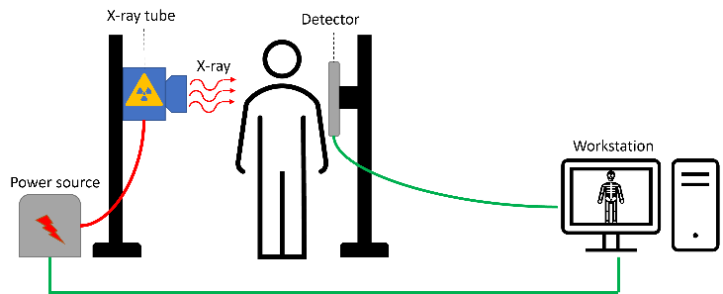

For each patient, the radiology technician register a request on the workstation in which the power source and detector parameters are prepared for an X-ray examination. The workstation communicates with power source and detector and tune them through issuing a chain of timing and control signals.

In this design the problem is that there is no specific standard for communicating with components. Each power source (and also detector) vendor has its own set of communication API and practices. The timing and control signals is not compatible in between the devices. Additionally, the communication channel in between workstation machine and peripherals are not standardized, some vendors are in favor of legacy serial protocols such as RS-232 while the other prefer modern protocols such as USB and wireless channels.

SyncBox is an open-source hardware platform to solve these problems. It provides vast interface for almost all available X-ray units . Additionally, its general-purpose input/output (GPIO) lines provide extension bus for future applications.

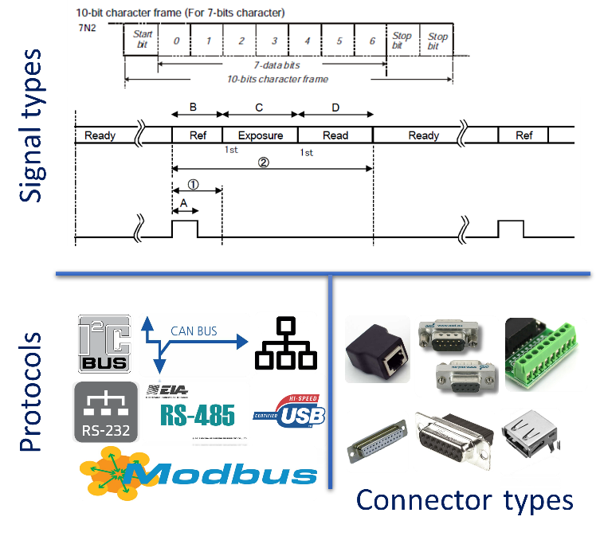

# Specific Requirements

This section of the **SRS** contains all requirements to a level of detail sufficient to enable designers to design a system to satisfy those requirements, and testers to test that the system satisfies those requirements

## Functionality

In this section we will review the required capabilities that are expected from SyncBox.

### Control and issue timing signals to with variety of detectors

Provide control channel for communicating with detectors.

### Communicate with variety of power sources

Provide communication channel for connecting to power source.

### Transfer data from detector through a high-speed channel.

Provide communication channel for connecting to power source.

### Process data received from detector.

Provide communication channel for connecting to power source.

### Provide emergency stop.

Provide emergency stop to cut X-ray and halt the mechanical units.

### Provide voice alarm.

Inform operator with voice alarm during exposure.

### Execute radiology workstation software.

Provide a platform for executing radiology desktop application.

## Usability

The SyncBox is used by radiology operators. There usability of the device should be designed from their perspective.

### Usability from a radiology operator’s perspective

The usability of the SyncBox is required to be easy. The only interface for output is power, and reset button. Additionally, it may provide optional LCD screen to display message to the users

## Reliability

Based on experimental examinations the SyncBox should be able pass the following criteria:

* Mean Time Between Failures (MTBF): six months
* Availability: 99% of the time
* Mean Time to Repair (MTTR): 24 hours
* Accuracy: 1ms in producing timing signals
* Maximum Bugs: 2bug/function
* Bug rate: minor and warnings

## Performance

The performance criteria for SyncBox:

* Response time for a transaction: 100 ms
* Throughput: 50 transaction per second
* Capacity: 1 Power source, 1 detector, and one workstation network
* Degradation mode: at least 98% stability
* Resource utilization: 2 GB ram, 100 GB hard disk, 1 GigE network

## Supportability

The project is developed by Altium designer 20. The source files are available on GitHub. Issues and feedbacks re provided from community over the GitHub.

## Design Constraints

The physical dimension should be 212x53 mm. The firmware language is in MikroC. As the workstation software is needed to be executed on Microsoft Windows, an intel based processing unit to required.

## On-line User Documentation and Help System Requirements

The online documentation is not mandatory, however the design documentations must be shared within the GitHub repository.

## Purchased Components

The microcontroller and processing unit must be available ahead.

## Interfaces

The interfaces are designed from the radiology technician and technical staff perspectives.

### User Interfaces

An optional LCD touch screen.

### Hardware Interfaces

GPIO, UART,CAN,LAN, HDMI, and LAN.

### Software Interfaces

For touchscreen we need a software.

### Communications Interfaces

Same as hardware interface

## Licensing Requirements

Altium designer and Microsoft Windows are required.

## Legal, Copyright, and Other Notices

SyncBox is an open-source medical project which is LGPL

## Applicable Standards

IEC 606001-2-8 Particular requirements for safety, IEC 61010-2 Safety requirements for electrical equipment for measurement, control, and laboratory use , IEC 61131-2 Equipment requirements and tests, ACR–AAPM–SIIM–SPR practice parameter for digital radiography, ACR–AAPM–SIIM technical standard for electronic practice, ACR–AAPM–SIIM technical standard of medical imaging.

# Supporting Information

Refer to Risk List document.